**Pass task 4.1 : Battleship Project Meeting**

**Meeting Agenda**

Date/Location: 28/3/19 at 15:30 at Swinburne University of Technology in A302

**Information Updates/Reminders**

* The next two weeks are going to be about understanding the legacy Battleship code base so that we can plan for the work to fix and improve it.
* Everyone should be able to use git, github wiki’s and Trello. Ask for help if that’s a problem.
* We’ll be using toggl.com to keep track of time.
* The Programming Help Desk (Room E620) is available to help us with programming for this unit.

**General Items**

* Each of the members have to download the code and make sure it can run on their machine
* Each member require a github account
* Required to create wiki page to record the details

**Decisions Needed**

* None (only general items requiring Actions this week)
* Everyone needs to download the old code and make sure they can run it.
* Need a Trello board created for this project and team. Actions and other details will be posted there. Columns used need to be decided. Someone needs to create and invite other team members.
* Need a Toggl team project to track the time the team uses. Someone needs to create and invite team members (using email addresses). We need to decide what activities to track.
* Need a github account for this project. (Project from last task can be used if suitable.) Existing code base can be added.
* Need github wiki pages to document project details.
* Need to find and list functional issues. What works the way it should and what does not? Put on wiki.
* Need a list of all the files, and what each file is for (description). Decide where this is stored. Put in wiki
* Are some files (code or resources) not being used or not needed? Create a list and share on wiki.
* What tools we can use to convert VB code to C# code? Someone (or several) people should investigate and report back next meeting so we can decide and then do the work of converting.
* What coding standards should we used for the project? Need someone (or several) people to investigate and report back at the next meeting so that we can decide.
* Are there any obvious TODO, BUG or FIXME comments in the code base that we should know about? Someone should check and report.
* How much of the code has been documented, and once converted what needs to be done. Someone should investigate and report.
* A list should be created to keep track of extensions ideas and new features that could be added (not bugs to fix). The work should not be done at this stage.

**Meeting Minutes**

Date/Location: 28/3/19 at Swinburne University of Technology in A302

Attendees: Marc Chai, Lim Jia Lok, Aldalton Choo

Start Time: [2:30 p.m.]

End Time: [3:30 p.m.]

**Decisions**

* None (only general items requiring Actions this week)
* AC, MC and LL needs to download the old code and make sure they can run it.
* LL will create a Trello board created for this project and team. Actions and other details will be posted there. Columns used is decided by LL.
* AC will create a Toggl team project to track the time the team uses. AC will invite team members (using email addresses). Activities tracked will be decided by each individual group members based on the task assigned to them.
* AC, LL and MC will create a github account for this project. (Project from last task can be used if suitable.) Existing code base can be added.
* MC will create the github wiki pages to document project details.
* LL will find and list functional issues. What works the way it should and what does not and put it on wiki.
* AC will list all the files, and what each file is for (description). Decide where this is stored. Put in wiki
* AC will decide if some files (code or resources) not being used or not needed? Create a list and share on wiki.
* What tools we can use to convert VB code to C# code? AC and LL will investigate and report back next meeting so we can decide and then do the work of converting.
* What coding standards should we used for the project? MC will investigate and report back at the next meeting so that we can decide.
* How much of the code has been documented, and once converted what needs to be done.LL will investigate and report.
* LL will create a list to keep track of extensions ideas and new features that could be added (not bugs to fix). The work should not be done at this stage.

**Actions**

* 28-3 Marc will create a new GitHub page and invite the other members
* 28-3 Lim Jia Lok will create a trello board and invite the other members
* 28-3 Aldalton will create a Toggl page and invite the other members
* 01-3 Marc will be researching the coding standards
* 02-4 Marc will create a wiki page to record any findings
* 02-4 Aldaton will remove any unneeded files
* 02-4 Lim Jia Lok will be testing to run the game
* 02-4 Lim Jia Lok will be checking the functionality of the game and list missing functionality
* 02-4 Lim Jia Lok will be checking for bugs of the game and list the bugs
* 03-4 Aldalton will be researching tools needed to convert VB code to C# and Lim Jia Lok will be coverting the VB code to C# code
* 03-4 All members have to report on their findings in the wiki.

Contribution on git hub :

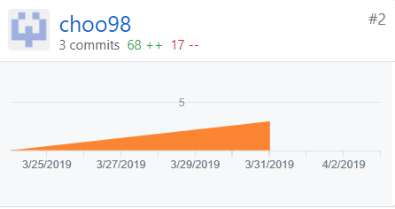

Figure (1) My contribution graph for week 4’s assignment

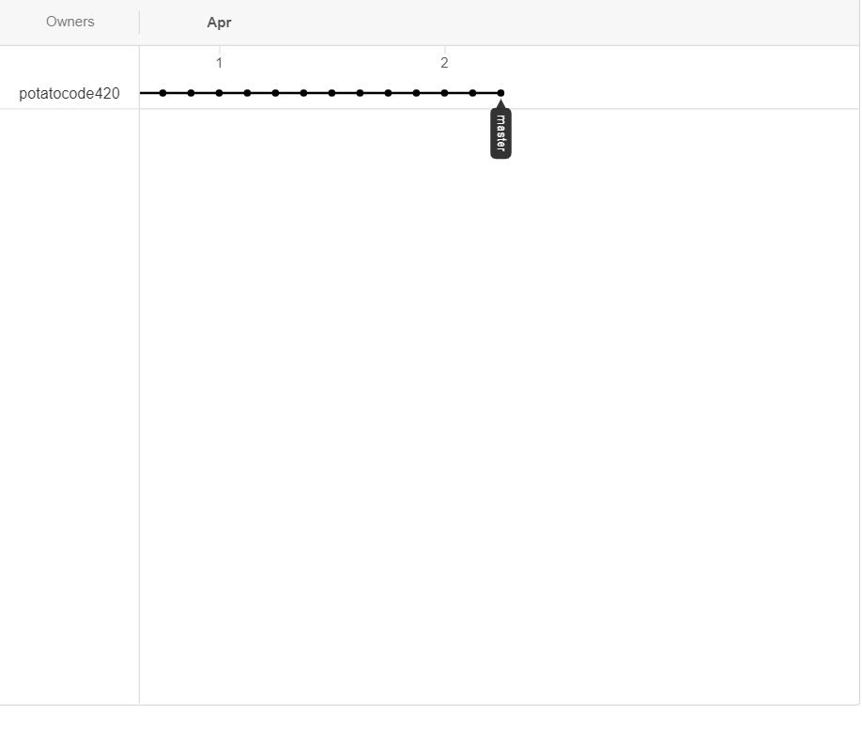

Figure (2) My network graph for week 4’s assignment

My task in week 4’s assignment was to list the files in the battleship folder and write a description for them. I was also in charged to find non-related files and deleting them. The last tasks that was assigned to me is searching for tools that can be used to convert VB code to C# code and I did this with Eddie. I searched the web for the converter which is <http://converter.telerik.com/> While Eddie did the converting process.

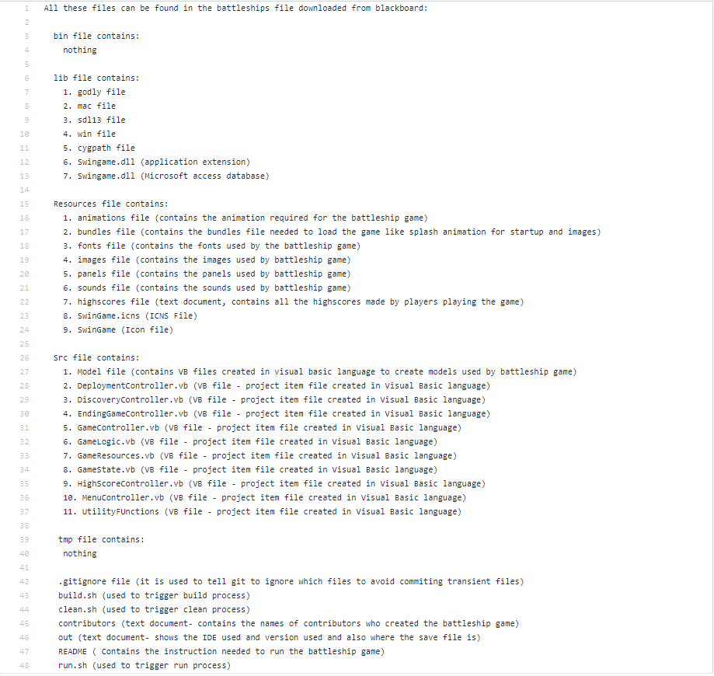

Figure (3) List of files found in battleship folder and their descriptions

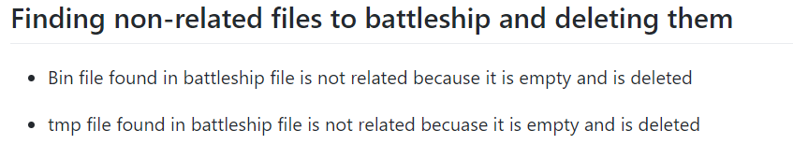

Figure (4) Listed down the non-related files and deleted them.

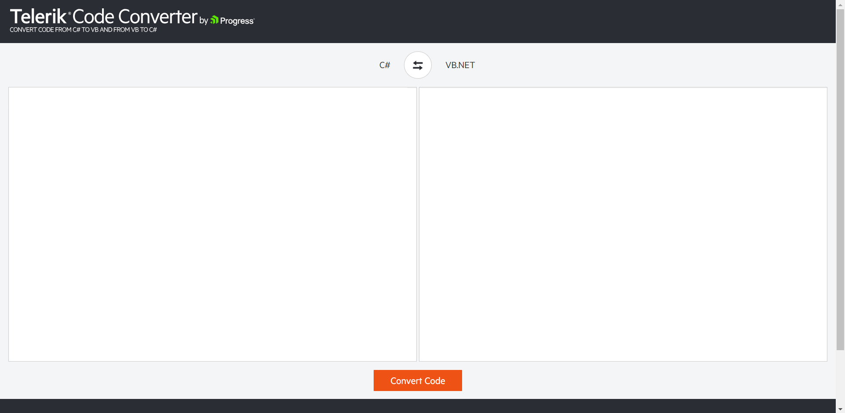

Figure (5) Example of converter used to convert VB code to C# code

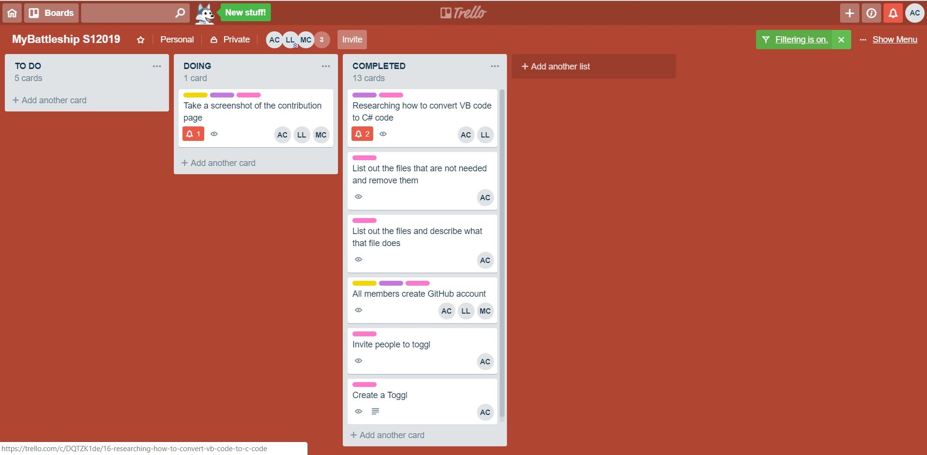

Figure (6) A picture of our Trello which shows which tasked I have done.

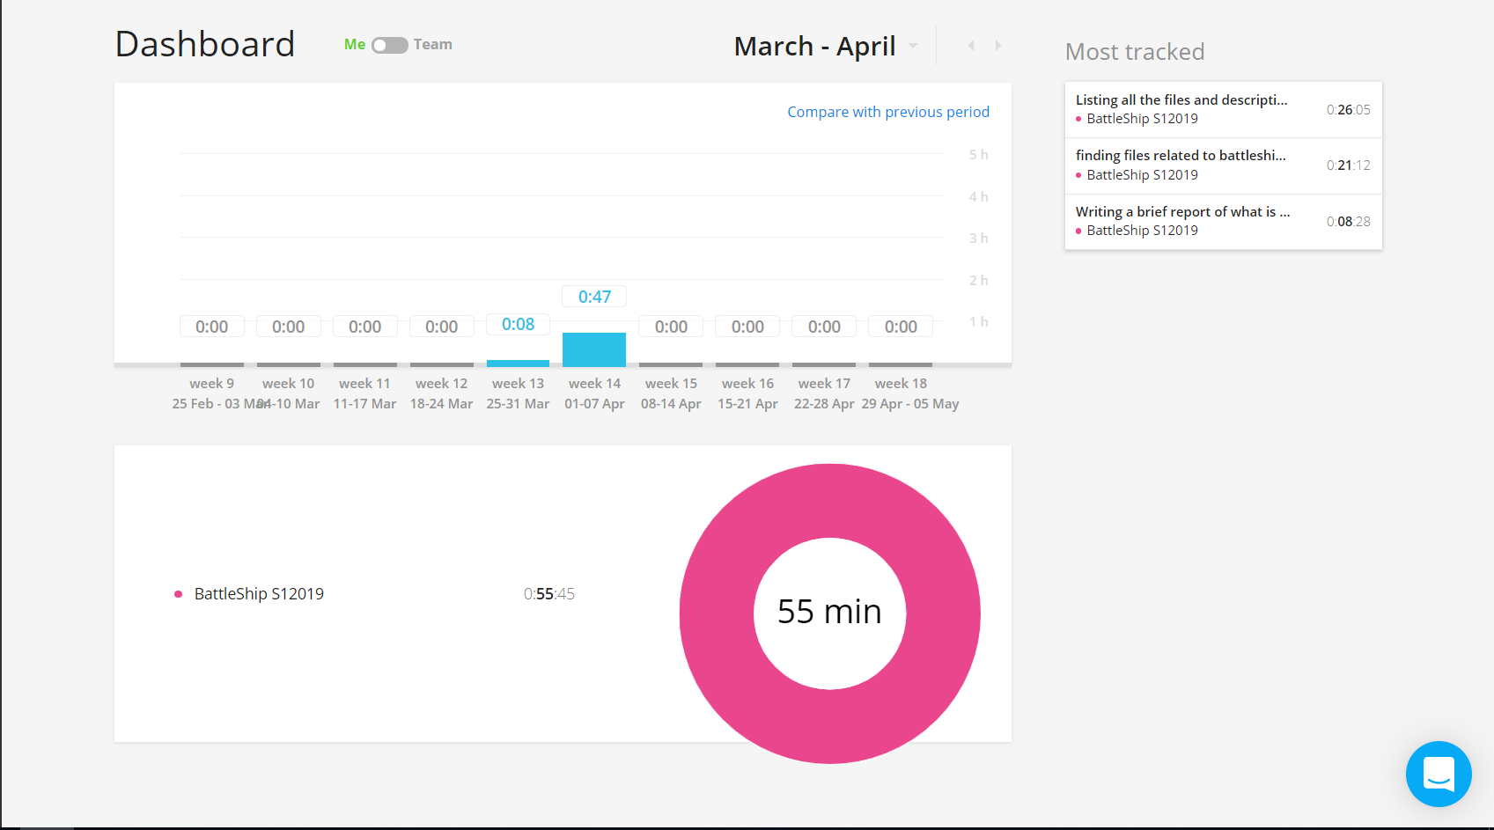

Figure (7) Toggl dashboard of my activities (AC)